Song Request Playlist

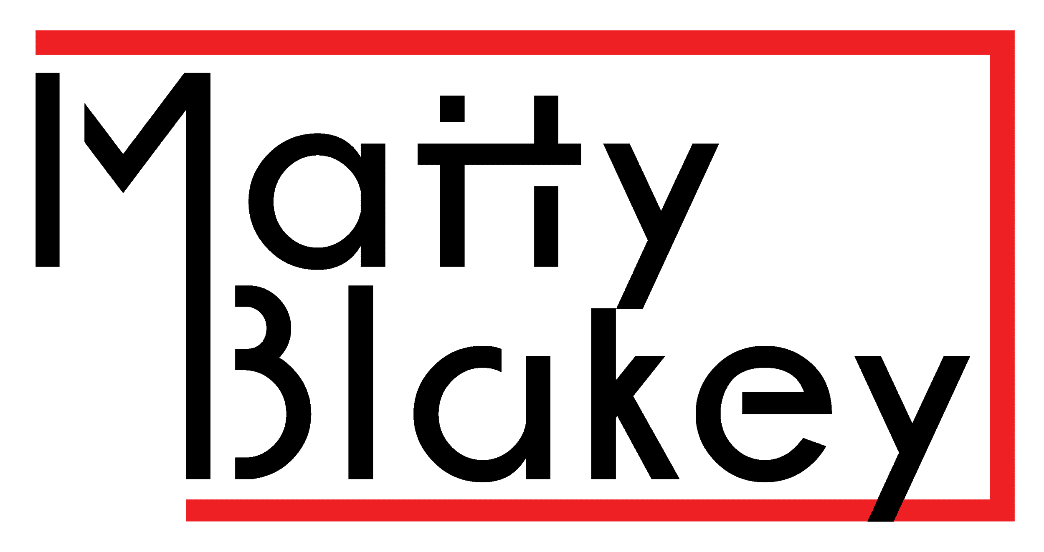

www.djmattyblakey.co.uk

Song Request Playlist
Help me get your party just right by filling out this music request form or attach a Spotify or Apple music playlist with some of your favourite songs. This allows me to get an idea of what songs will get you singing to your heart’s content. Simply send this form back to me with your event date as the subject.
Email - contact@djmattyblakey.co.uk
Post - 58 River Holme View Brockholes, Holmfirth, HD9 7BP

Your Name -
Your Email -
Your Number -
Your Event Date -
Your Event Type -
Your Venue Name -

Spotify/ Apple Music Link -

Please add around 40 songs that you want to hear at your special event below.

Song Name | Artist Name

